**PRACTICAL NO.7**

**AIM:** Implement FOSS-Cloud Functionality VSI (Virtual Server Infrastructure) Infrastructure as a Service (IaaS), Storage , VSI Platform as a Service (PaaS)

**SOLUTION:**

**1) Implement FOSS-Cloud Functionality VSI (Virtual Server Infrastructure) Infrastructure as a Service (IaaS), Storage**

**Step 1:** Download and install FOSS-Cloud from its official website.

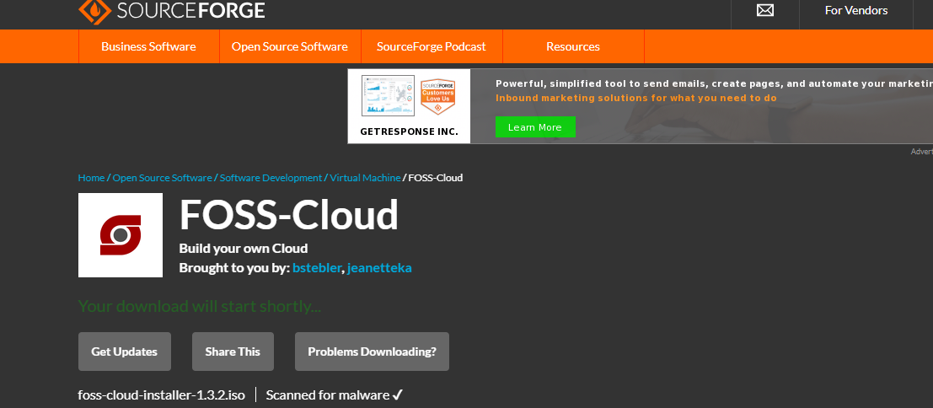

**Step 2:** Open Virtual Machine and create new Virtual Machine. Add your foss cloud iso file path at ISO Image.

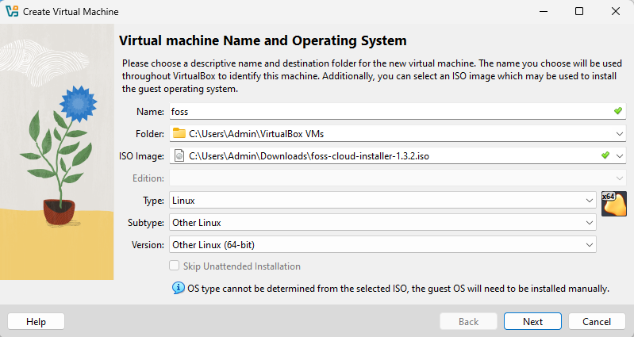

**Step 3:** At the time of setup allocate Base memory.

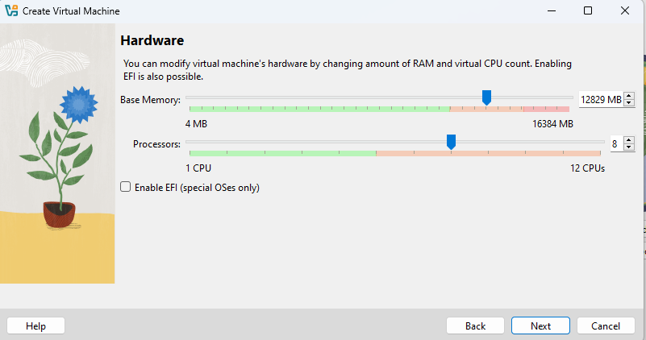

**Step 4:** Create Virtual Hard Disk and give disk size.

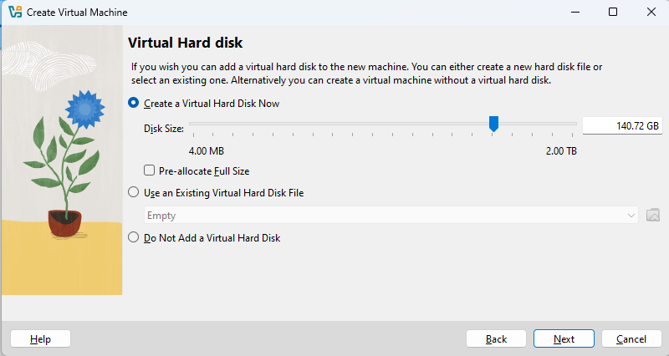

**­Step 5:** Click on settings.

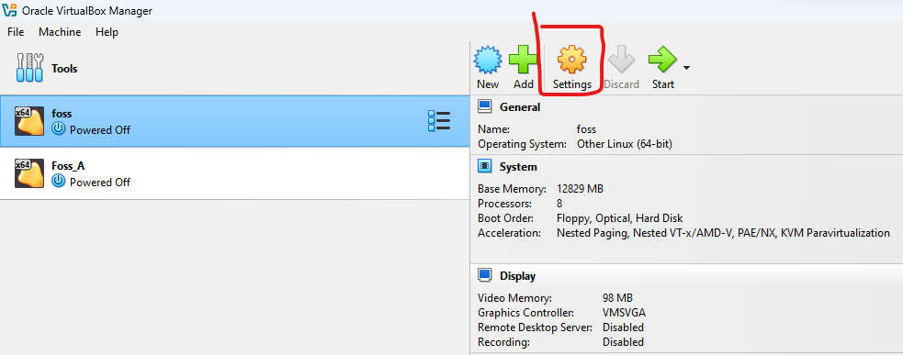

**Step 6:** Select System 🡪 Display & add video memory.

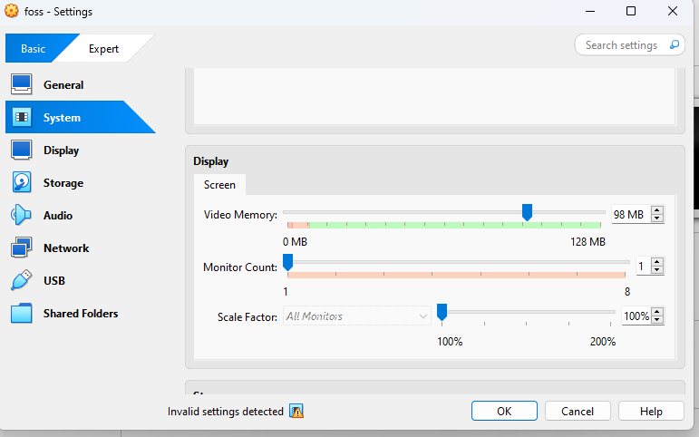

**Step 7:** Select Network & add Bridge Adapter. Then USB & SELECT USB 2.0 (OHCI + EHCI )Controller.

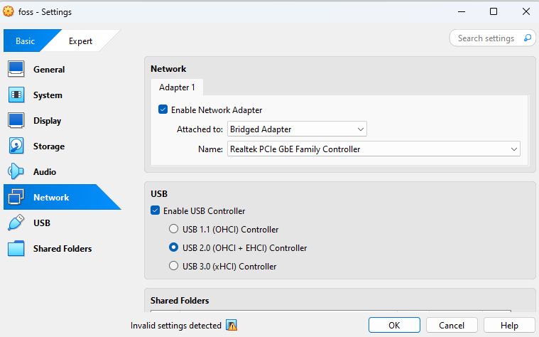

**Step 8:** Block/Off the firewall from settings.

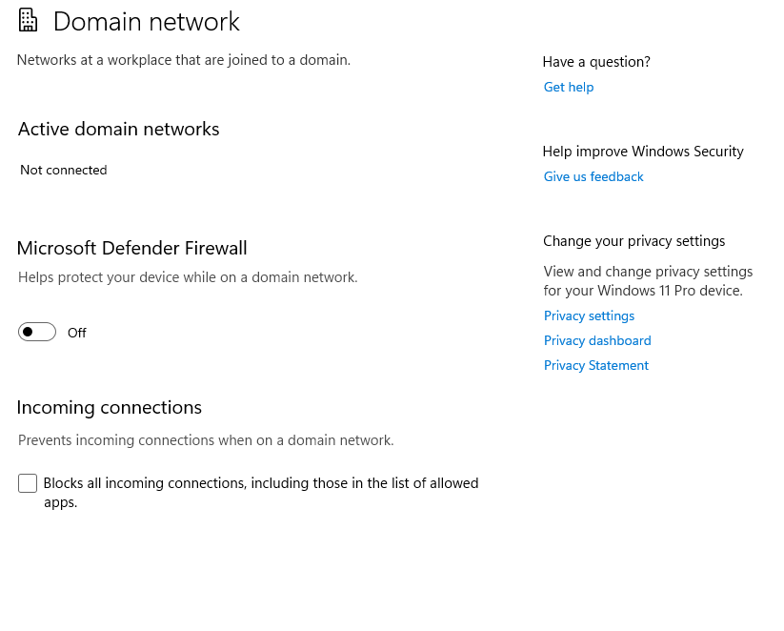

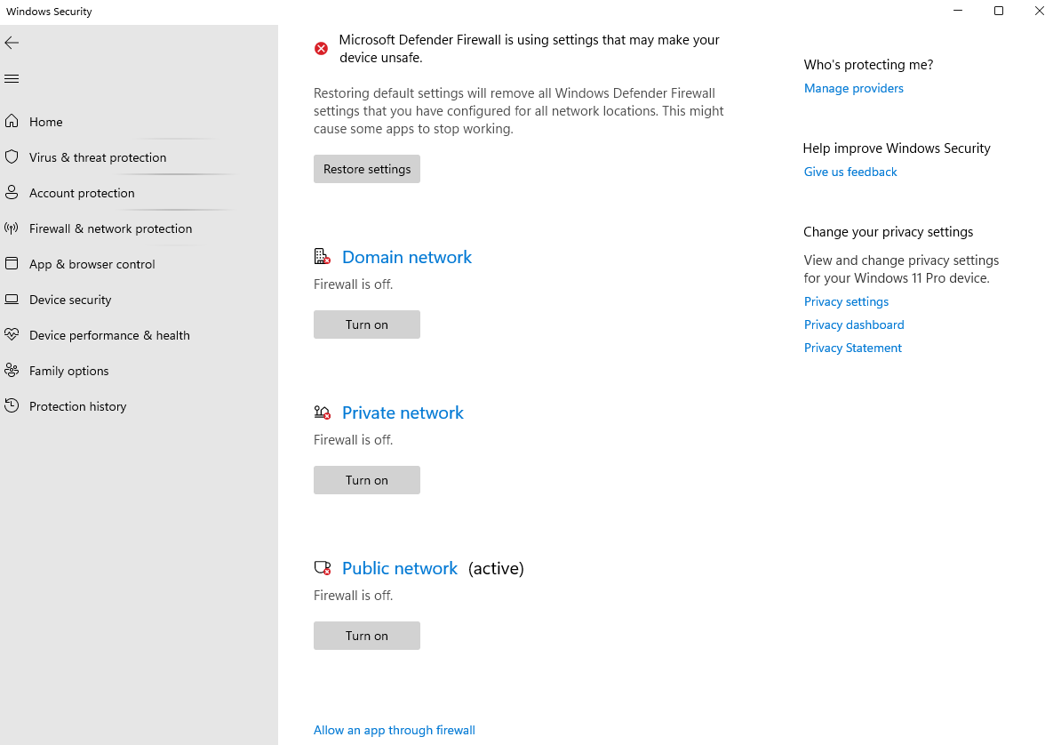

**Step 9:** Select 1st option here and Enter.

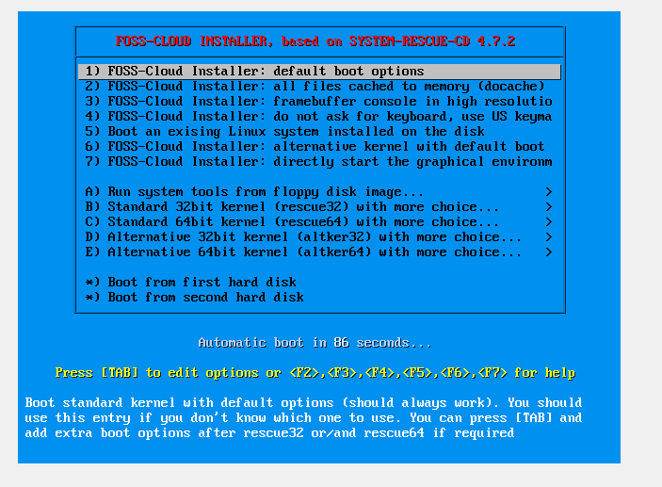

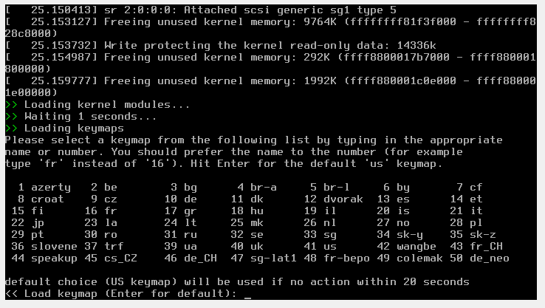

**Step 10:** Type yes to start the installation.

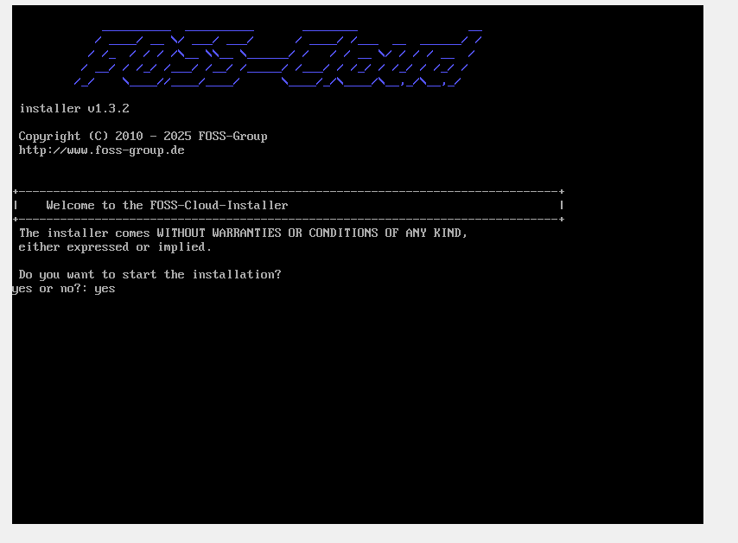

**Step 11:** Open cmd and type following command and enter.



**Step 12:** Now start with the FOSS virtual machine.

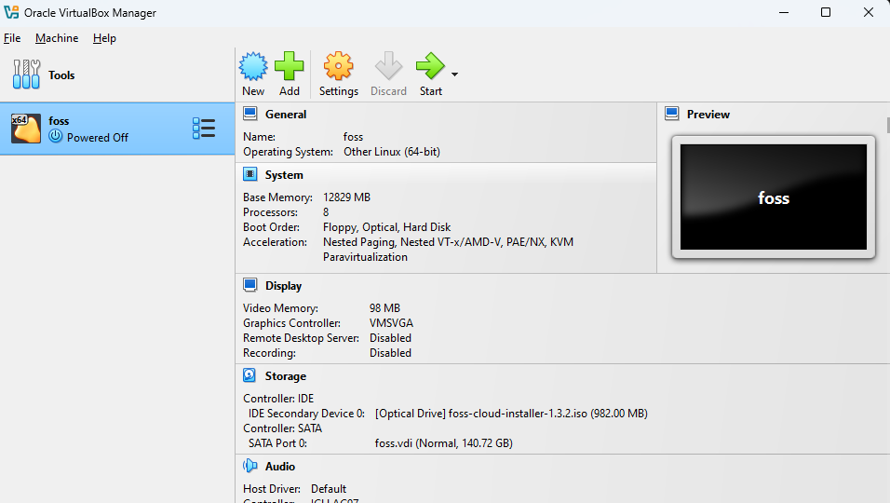

**Step 13:**  Enter Number 1 to install Demo-System server.

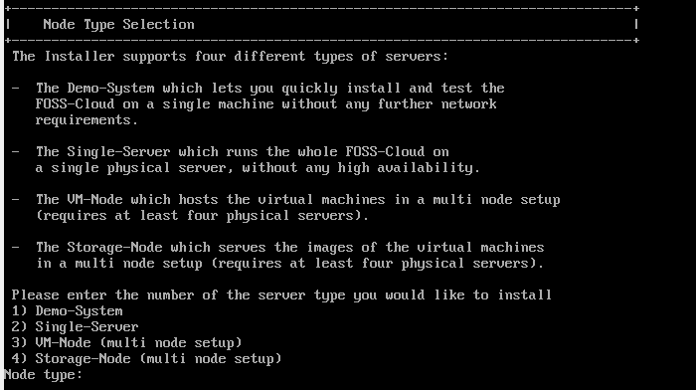

**Step 14:** Add device name sda.

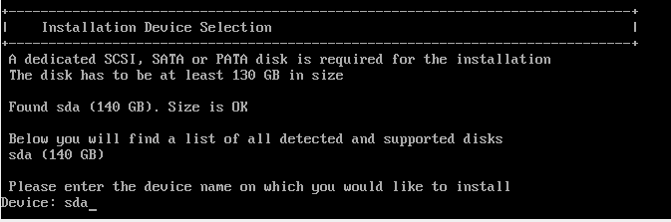

**Step 15:** Enter yes to continue for installation of Device Partitioning.

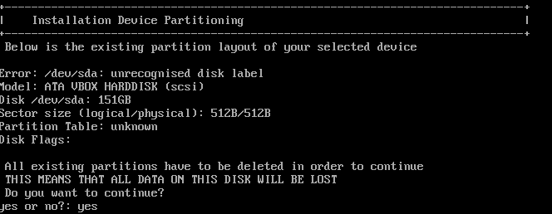

**Step 16:** Add available Ethernet device name eg:enp0s3

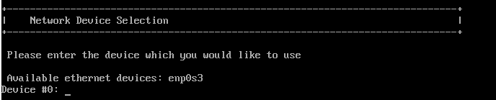

**Step 17:** Enter yes to use automatic network configuration and enter yes.

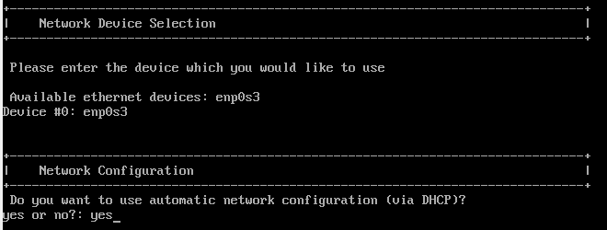

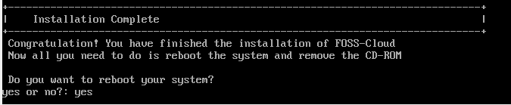

**Step 18:** Now select Boot from first hard disk and enter.

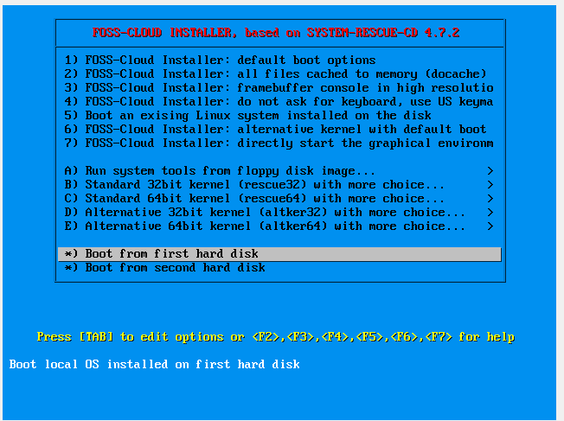

**Step 19:** Select FOSS-Cloud and press Enter.

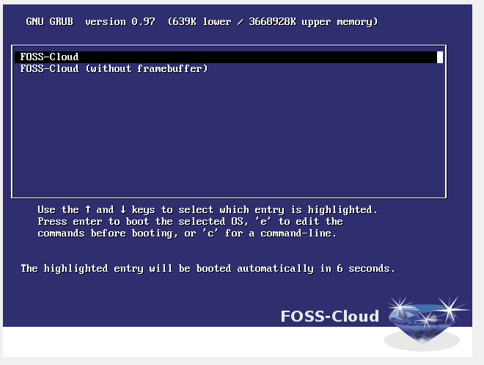

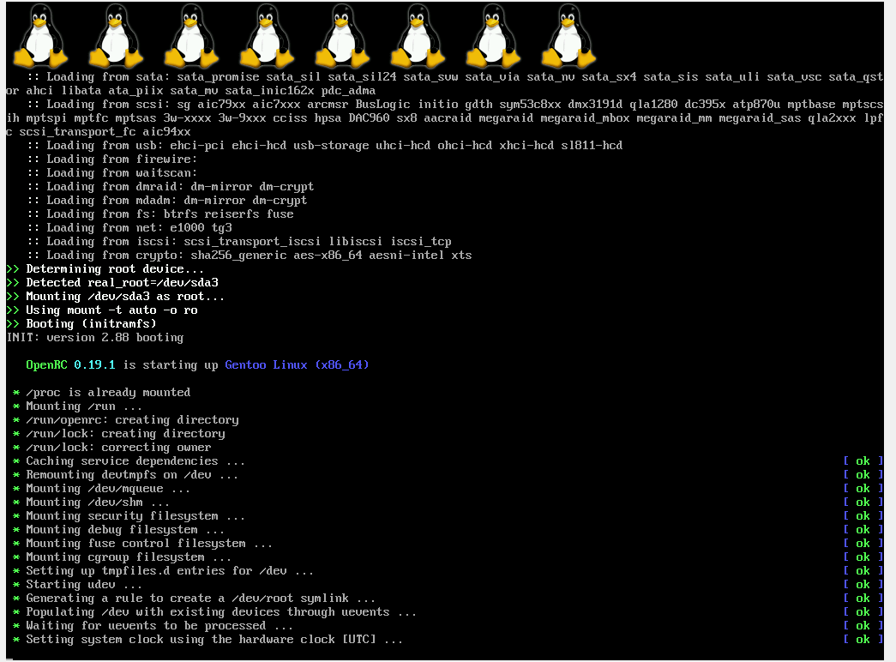

**Step 20:** Now, login with user credentials given here.

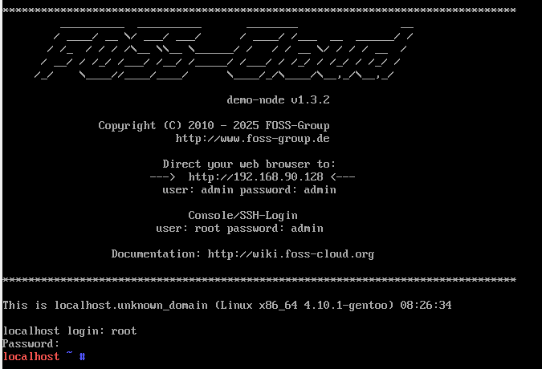

**Step 21:** Add following command in front of localhost fc-node-configuration –n demo-system –password admin. Press Enter and the installation process will started.

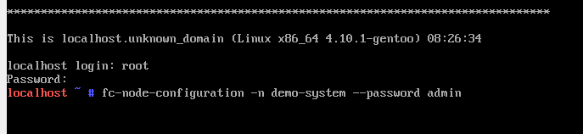

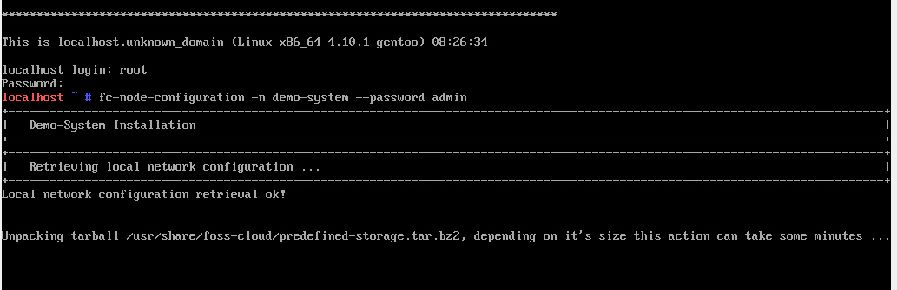

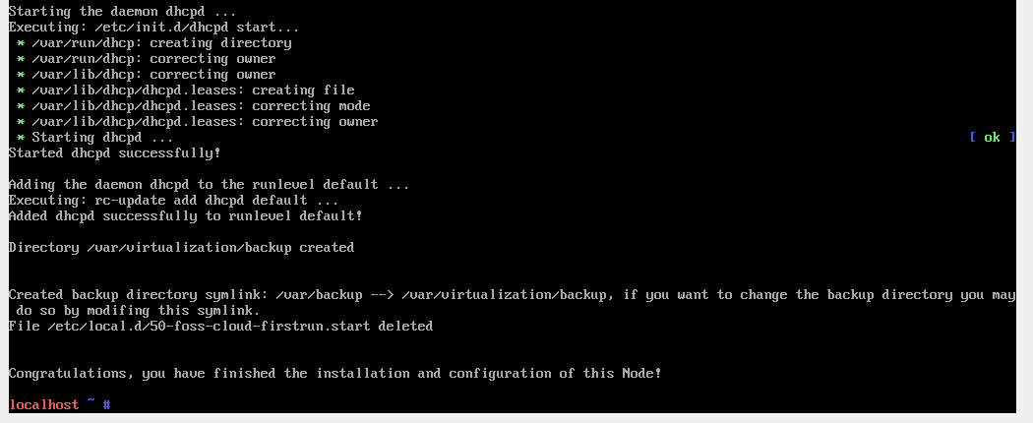

**Step 22:** Type ifconfig command to get inet of the device.

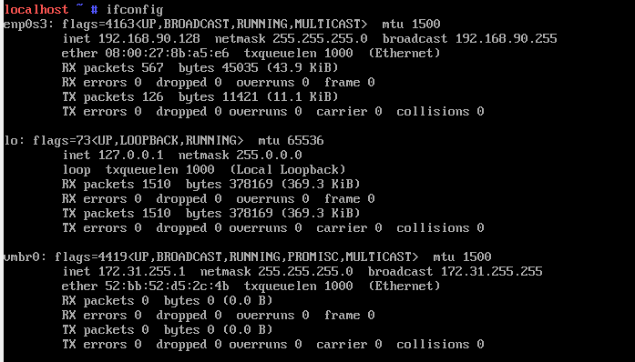

**Step 23:** Open browser add ip address & press enter

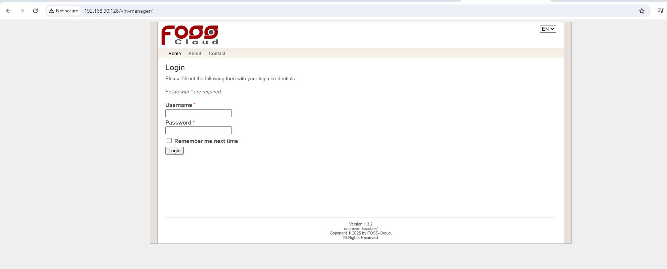

**Step 24:** Login with the credentials.

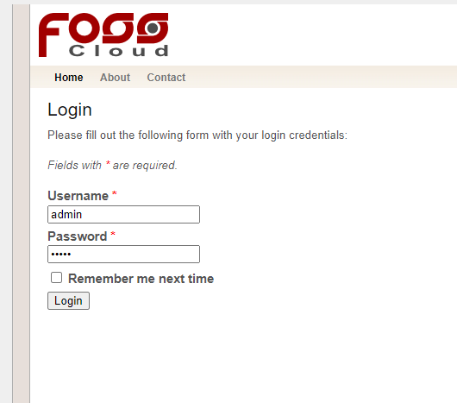

**Step 25:** You are done with the FOSS Cloud installation & setup.

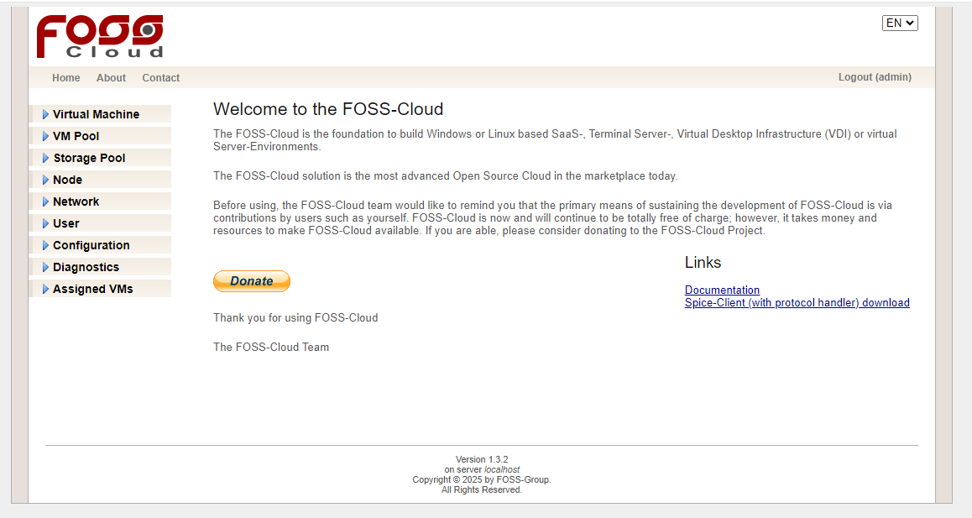

**2) Implement FOSS-Cloud Functionality - VSI Platform as a Service (PaaS),**

**Step 1:** After installation, it will show you an IP Address. Put it in your browser to access your administration page.



**Step 2:** Now select virtual machine 🡪 Upload ISO File & choose iso file to upload. You can upload either Ubuntu iso file or foss iso file or any other.

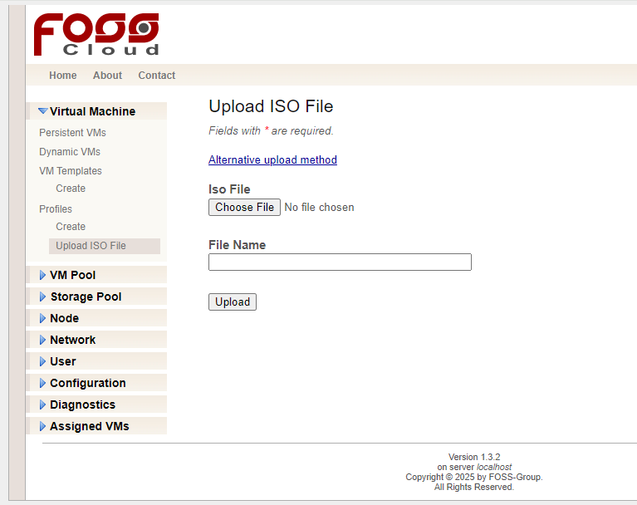

**Step 3:** Add file name after choosing the iso file.

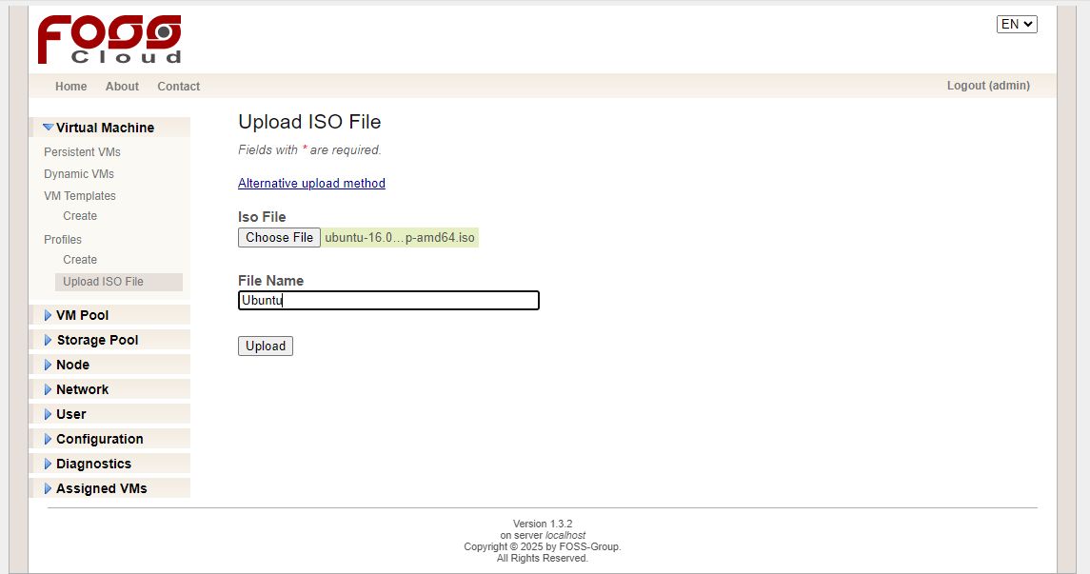

**Step 4:** Now click on upload button.

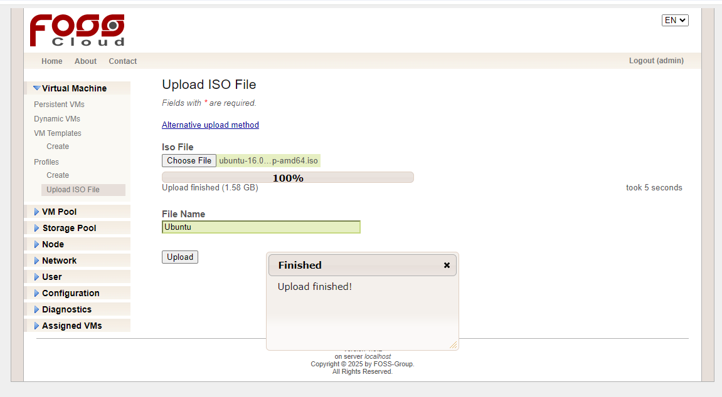

**Step 5:** Now after uploading file. Select create under the profile section.

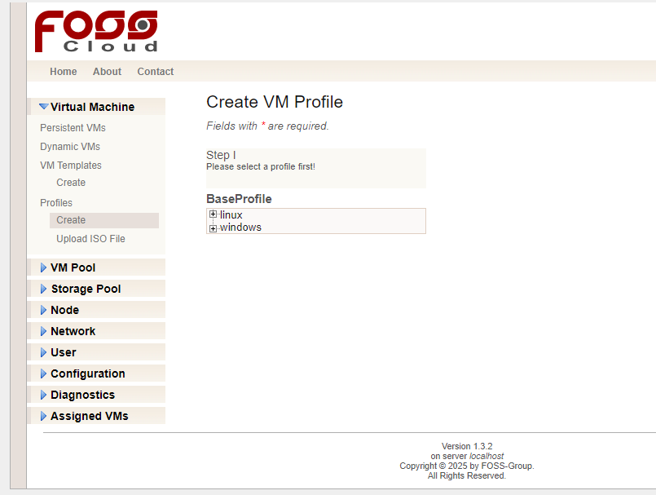

Step 6: Select in

* Step 1 : select windows 🡪 en-US.
* Step 2: Select iso file. Give Name to your Vm Profile. Add Description. Add memory and remaining details as given or provided & click on Create button given below.

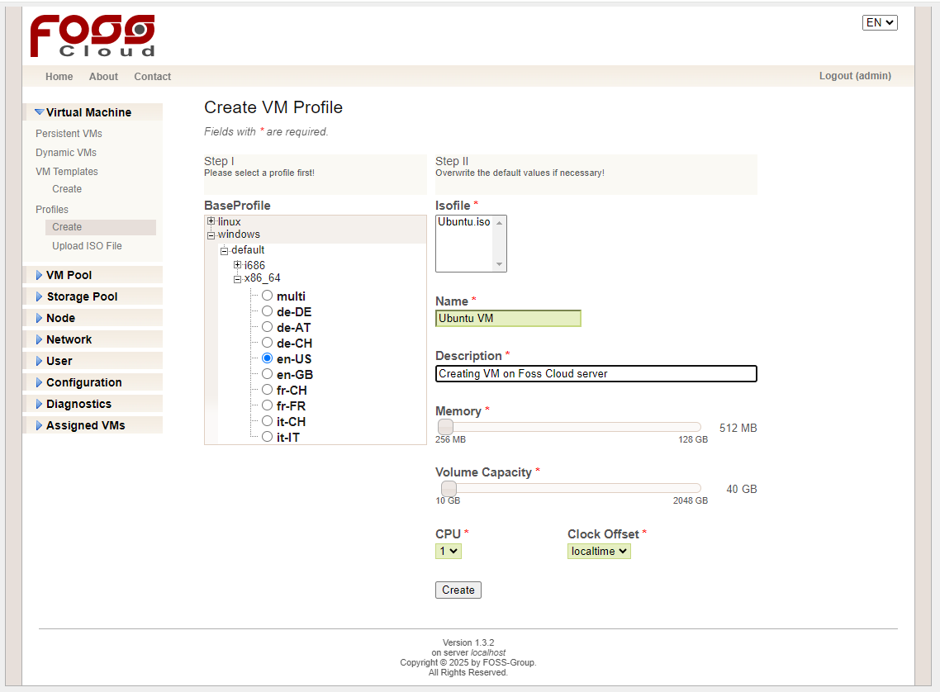

**Step 7:** After creating following page will open.

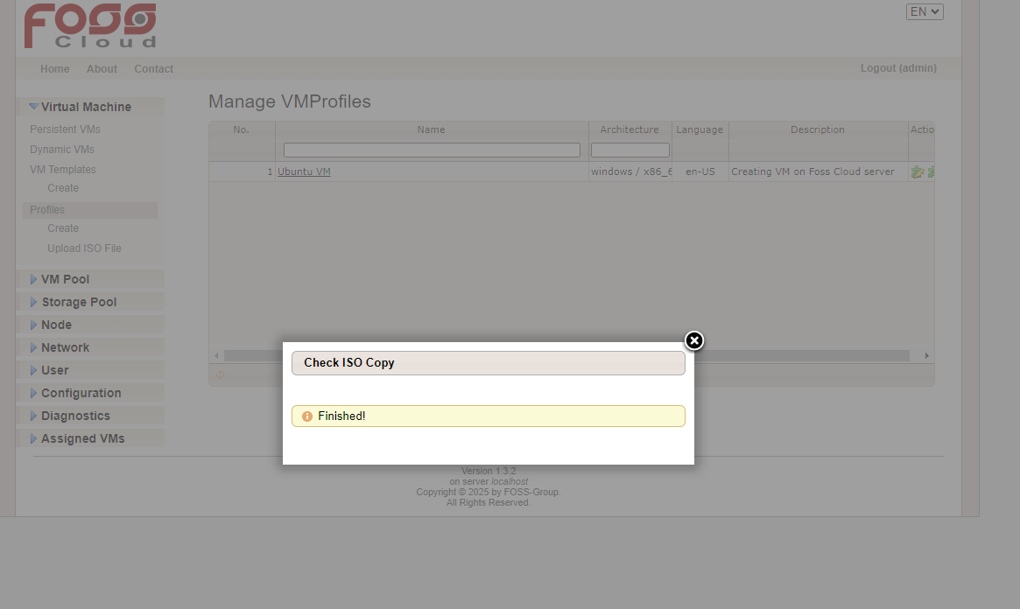

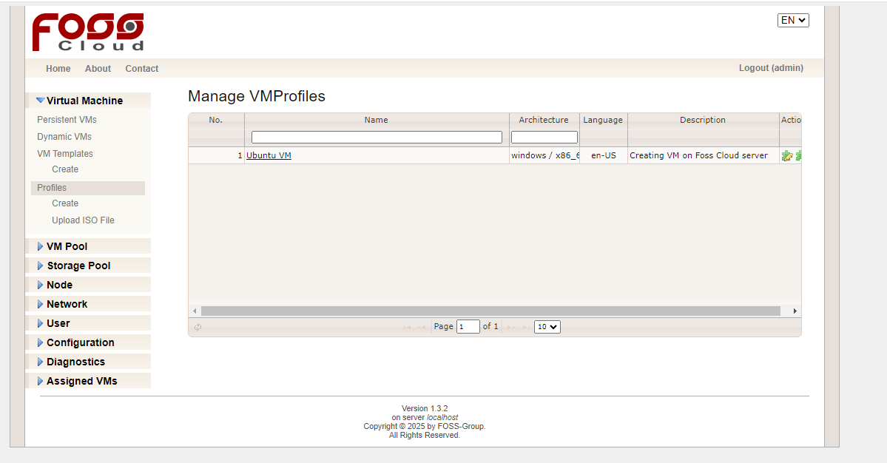

**Step 8:** Now, create VmTemplate.

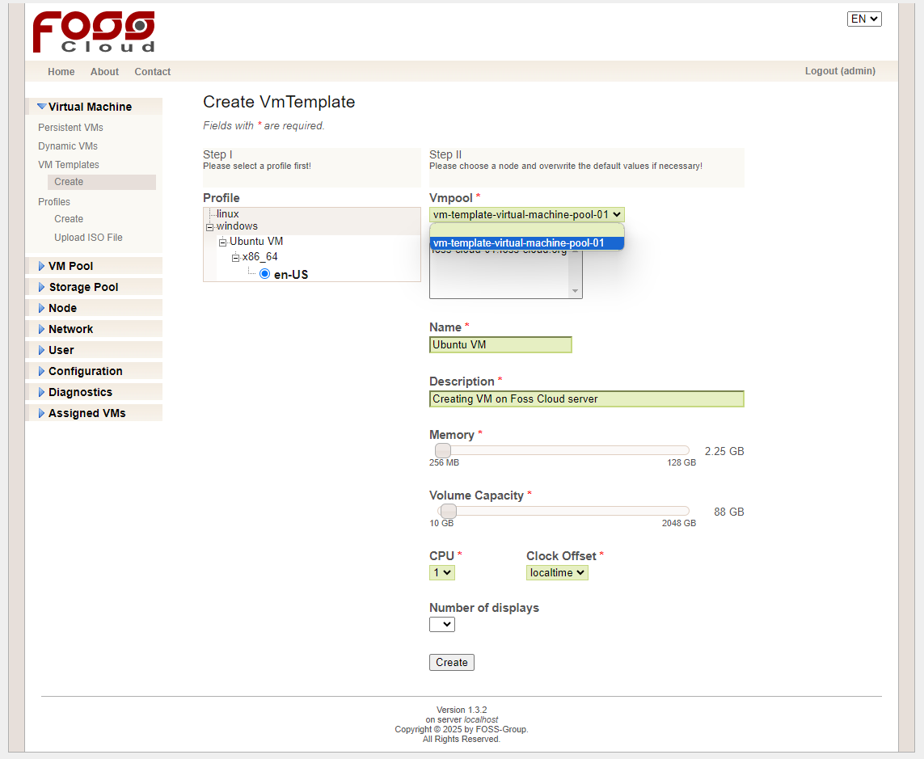

**Step 9:** After creating template Manage VMTemplate page will be displayed. Status is stopped to start it click on green Arrow in Run Action to start the status.

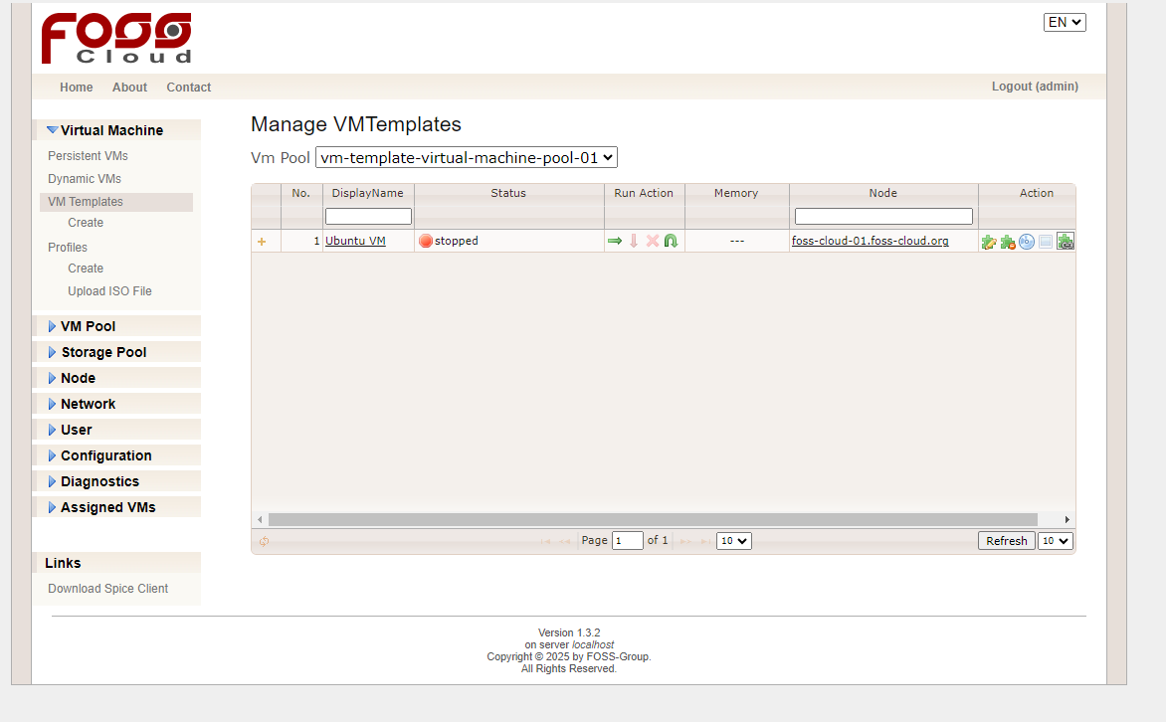

**Step 10:** Here, you can see the status is running.!

